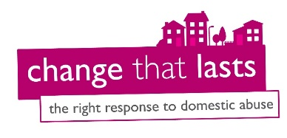
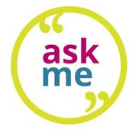
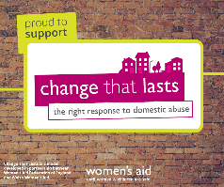
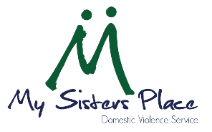
MSP

Community Ambassador – Expression of Interest Form
Thank you for showing an interest in the Ask Me Scheme. Please complete the following form to sign up to attend the training.
The information we request from you in this form will be used by the My Sisters Place team and stored in our cloud system to help us monitor bookings, keep track of trained ambassadors, and create evaluation reports on the Ask Me programme. This information will be retained for an indefinite period of time, and sensitive personal information used to monitor demographics will be anonymised. By submitting this form, you consent to us retaining your information. If you would like your details to be erased from our system, please let us know on 01642 241864 or contact Jess Taylor on 07925648089 or jessica.taylor@mysistersplace.co.uk

About You:
- *Full Name
- * Email address
- * Date of Birth
- * Contact Number
- * Address
- *Why do you want to become a community ambassador?
- * Tell us a little bit about yourself e.g work, hobbies etc.
- *How did you hear about the training?
- Via an email newsletter (please tell us which one below)
- Via Social Media (Facebook, Linked In etc)
- My Sisters Place staff member
- I saw a poster advertising the scheme
- Via another ambassador
- Volun-tees
- Word of mouth- friend/family member/colleague/other
- Other (please specify)

Attending Training
The scheme is aimed at community members and is not a professionals training. It is for anyone over 18 who live/work/volunteer/study in our local area.
- *Which training date would you prefer to attend? (Please highlight all that apply).*Online sessions are shorter as you will be expected to do pre-reading beforehand which will be sent to you via email the week prior.
Session Type | Dates | Times | Location | Tick
Online | Mondays 6th and 13th June | 9:30am-1pm | Zoom
Online | Mondays 20th and 27th June | 6pm-9pm | Zoom
Online | Thursdays 23rd and 30th June | 6pm-9pm | Zoom
Online | No dates suitable for me at present

Talking about domestic abuse
Domestic abuse is an emotive subject and many people have been affected by it. We want to ensure that everyone attending the training feels safe and as comfortable as possible so please email us if you would like to discuss the training content, the role, any personal triggers you’d like us to be aware of or to discuss support that you need via jessica.taylor@mysistersplace.co.uk. Alternatively, the National Domestic Violence Helpline is available 24/7 for confidential emotional and practical support on 0808 2000 247.

Ask Me Social Media Pages
We would love to keep you updated about our vital work and the ways that you can help end domestic abuse for women and children. These updates may include information about fundraising, campaigns, and events. Follow us on Facebook and Instagram @askmeboro & @mspmbr. We even have a private group full of ambassadors who have already completed the training.

- Supporting you on the training- Please let us know if there is anything we should know to ensure you are comfortable and get the most out of the training.

Thank you for completing the expression of interest form- please return to us and we'll be in touch soon to confirm your training space.
In the meantime if you have any queries please contact jessica.taylor@mysistersplace.co.uk

