Community Ambassador Ask Me Scheme 2022

Do you want to help make a difference to women in your local area?

People within a survivor's community are often the first to know that domestic abuse is happening. But lack of understanding and confidence can make people afraid to talk about it, and unsure of how to respond when someone speaks out. Survivors have told us they can feel judged, isolated, or silenced by their community. We are changing that through the Change That Lasts Ask Me scheme.

The project equips you with an understanding of domestic abuse and how to respond to survivors to enable the community to play an active role in ending domestic abuse. We offer free online or in person training courses to those from all backgrounds and identities where you will learn how to challenge stereotypes and how to listen to, believe and direct survivors to specialist support.

After the training, ambassadors are given resources and support to share what they have learned with those around them in ways that feel most comfortable to them. They are encouraged to start conversations and help others to better understand the barriers that survivors face in speaking out. An ambassador can commit as much or as little time as they can give. We’ll keep in touch with new opportunities and events such as meet-ups, campaign involvement and volunteering. The training we have available is as below:

- Online: Mondays 21st AND 28th November.
Start: 10:00
Finish: 13:00

If you would like to discuss other training opportunities, sign up or be placed on the waiting list, please email me on jessica.taylor@mysistersplace.co.uk
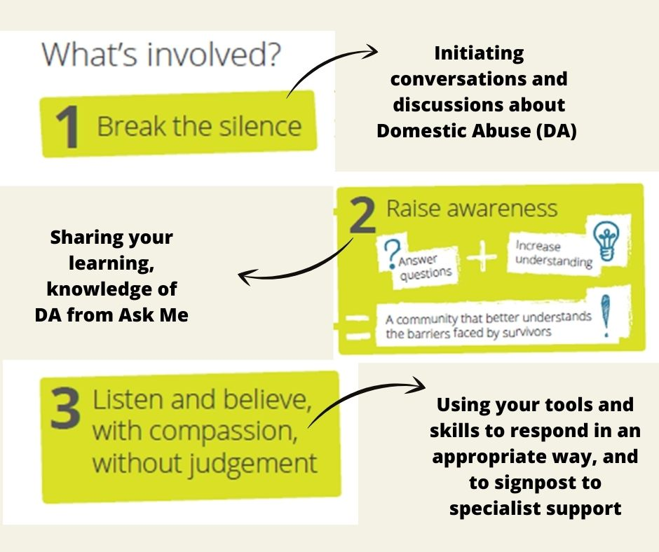
Jessica Taylor

Community Development Worker
My Sisters Place Domestic Abuse Service

( 07925648089
( 01642 241864
: https://www.facebook.com/askmeboro

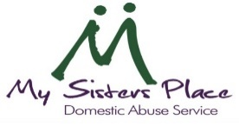
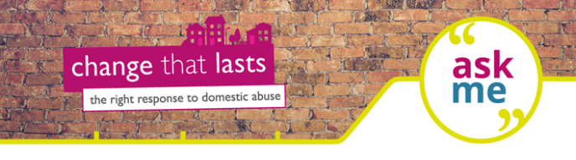www.mysistersplace.org.uk

