Status:
Employed
Not Employed
Primary School
Secondary School
College
University
In Training
Other
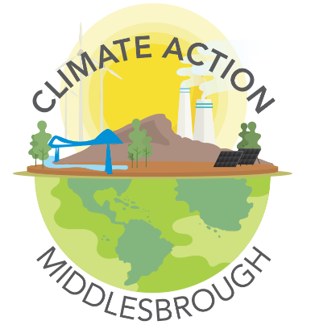
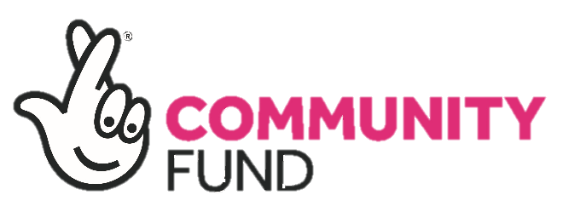
Climate Action Middlesbrough
Sign Up form
Climate Action Middlesbrough (CAM) is a new programme to support communities in Middlesbrough to reduce their carbon footprint and encourage changes towards more sustainable lifestyles.
Detail:
Full Name:
Date of Birth: |  | Age:
Gender:
Nationality:
Address:
Email Address:
Contact Number:

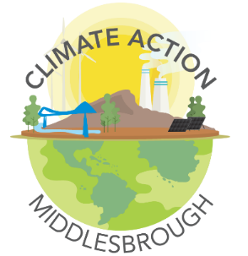
PHOTOGRAPHY/VIDEO RELEASE
- We will sometimes photograph/video our session and use it for our advertising, publicity materials, posters and funding applications (this list is not exhaustive) but we will only share images/clips in legal and appropriate settings.
- If you are over 13 years of age, we seek your consent to allow Actes the absolute right to use the images resulting from the photography/video filming and you understand that you do not own copyright or have any rights of ownership or other claim over the images.
- For those under 13 years of age Actes will seek permission from a Parent/Guardian of a young person/child under the age of 13 years old, to take photos or videos of your young person/child whilst involved with any Actes activity/activities/residential.
- You can withdraw your consent for images to be used without any detriment to your membership. If you withdraw your consent images will be removed and/or destroyed as soon as possible.

NAME: __________________________________
SIGNED: __________________________________
DATE: ___________________________________
