**Community Champion**

**Training:**

**Community Champion Overview and role profile**

**An Overview:**

Championing National Parks for Everyone (CNPfE) is a National Lottery Heritage Fund project which aims to increase the diversity of visitors to the National Parks through activities that develop skills, confidence and awareness of the benefits of National Parks.

The Community Champion Training Programme is the heart of the Championing National Parks for Everyone project. The project aims to work with adults from culturally diverse communities to build their skills and confidence to lead their own visits and to create networks with local National Park communities, staff and other participants. The training programme has been co-designed with diverse communities through the development stage of the project.  The training is free.

The Yorkshire Dales, North York Moors and Peak District National Park Authorities will each deliver three cohorts of Community Champion Training throughout 2025.

***A Community Champion is ...***a curious, adaptable and open-hearted individual who is eager to explore the natural world, connect with other like-minded individuals and inspire interest in others about our National Parks.

To apply to become a Community Champion you must be

* from an ethnically and culturally diverse background
  + For clarity, this means people who are from Black, Asian and Minority Ethnic communities. This therefore includes people from marginalised White ethnic groups, for instance refugees from Ukraine, people who are Roma or people or are Gypsy or Irish Traveller.
* Live within the defined focus areas for the North York Moors National Park which are Redcar and Cleveland, Middlesbrough & Stockton
* Over the age of 18
* Be able to attend all training sessions
* Have an interest in leading groups in the outdoors

The opportunity is in three parts:

* Six days of training run by the National Park
* Planning and delivering your own event for others from your community
* Further opportunities with Peak District Mosaic after training

The six training days will be delivered on weekends, spanning across six months. There will be three 1-day training sessions, a weekend residential consisting of 2-days and 1-night, and a final 1-day celebration event.

Embedded within the training is the opportunity for participants to run their own activity and to put their newly-learnt leadership skills into practise. Participants are given a bursary to fund their own activities. NB: The bursary can only be accessed upon successful completion of the Community Champion training and submitting an activity plan to the Project Officer.

Community Champions will continue to be supported by Peak District Mosaic after training, with the offer of future training opportunities and CNPfE networking events where Community Champions from all three National Parks get together to share experiences and practise.

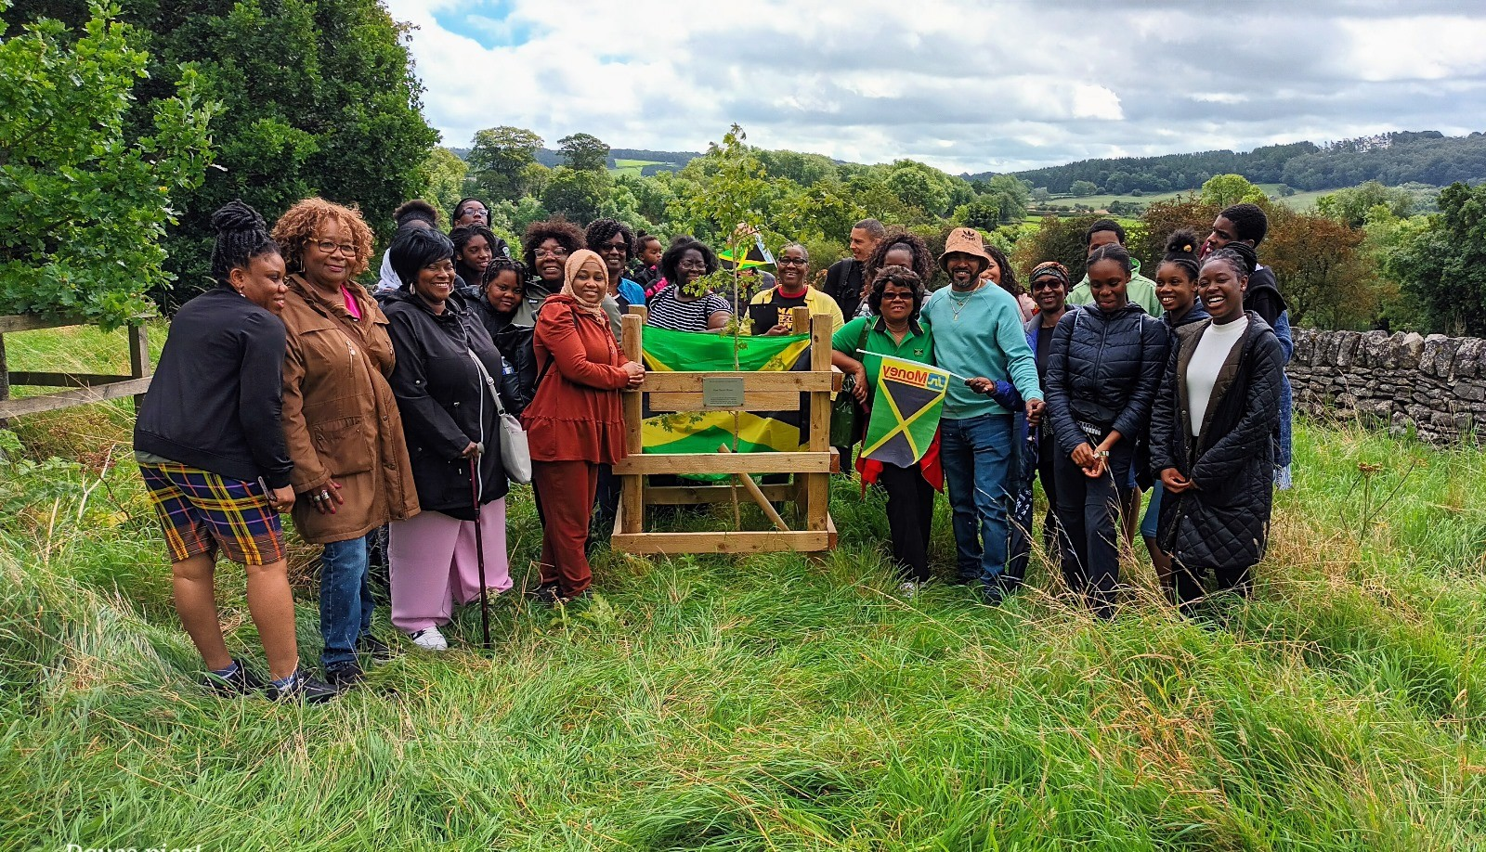

Community Champion Training in the Peak District.

**Location:**

Training will be delivered within the North York Moors National Park. Each session is made up of some indoor training (within a National Park Authority venue or village hall) and time exploring outside (either through guided walks or planned activities).

**Training Content:**

The training will include:

* **Developing knowledge about your National Park**: this could include geology, wildlife, botany, conservation topics, local heritage and culture.
* **Meeting local stakeholders**: developing networks with businesses, staff and locals in the National Park
* **Walking Skills**: things to consider while out walking.
* **Leadership Skills in the Outdoors**: navigation, health & safety and managing groups in the outdoors.
* **Planning:** how to successfully plan activities for your community in the National Park
* **Developing Confidence:** enhancing delivery and decision-making skills to aid leadership in the outdoors.

**What you will do as a Community Champion:**

**Commitment**: We ask that participants commit to the full duration of the programme: four Saturday sessions, the residential and the celebration event.

**Individual participant delivery:** After training, participants are expected to deliver their own session in their National Park to their communities. Staff and Mentors at the National Park will support in the planning of this. We ask that participants commit to their individual deliveries.

**Share knowledge and skills with the training group:** Every participant and staff member will have different skills and experiences. The training is designed so that participants can bring their own knowledge and lived experiences and that differences are respected and celebrated.

**Be a positive role model:** You will demonstrate care for fellow participants, an interest in National Parks and respect for the environment.

**Evaluation and feedback:** You will be asked to complete evaluations and reflections throughout the Training.

**Keep yourself and the group safe when you run your own events:** you will play an active role in the safety and well-being of the group and anyone who is in the vicinity of activities. This includes following health and safety and safeguarding requirements, being familiar with and taking account of risk assessments and challenging actions and /or conversations that you consider could cause harm.

**Community Champions will be:**

* Friendly and approachable and enjoy working with people
* Some participants may have no prior knowledge of National Parks, however some previous experience and understanding are also welcomed.
* Have good communication skills, able to impart knowledge in a manner appropriate to the audience
* Flexible, adaptable and self-reliant
* Willing to take part in any relevant training opportunities and updates.
* Happy to follow National Park guidelines and policies.
* A team player.
* Committed to running events for others as part of your Community Champion role.

**Practicalities:**

1. **Better Impact**: Peak District, North York Moors and Yorkshire Dales Authorities each manage and support their volunteers in different ways. Participants of Community Champion Training will register to Better Impact, a platform for sharing information and volunteering activities. On Better Impact, you will need to;

* Be registered with up-to-date emergency contact information
* Have read our Lone Working and Buddy System for Volunteers procedure
* Make Fitness to Volunteer, Health and Safety and Driving declarations

1. **Supervision & Support**: Participants undertaking Community Champion Training are under the direction of the CNPfE Project Officer North York Moors National Park.
2. **Equipment**: Participants will be given appropriate equipment to complete the training. This includes;

* Waterproof Trousers
* Waterproof coat
* Boots
* Rucksack

1. **Expenses**: There is a bursary for participants of Community Champion Training. This bursary is for travel to training, caring responsibilities and for equipment. Please indicate in the Application Form if you would like to claim the bursary. We will have a further discussion with you about this ahead of the programme starting. There is also a bursary of up to £300 per participant to deliver your own event.
2. **Organising and recording information:** Each participant will be given a Community Champion Training folder. The folder will contain important information about future sessions, specific handouts relating to individual sessions and information for planning your own delivery. Please look after and bring the folder to all sessions.
3. **Communication**: Participants will receive communication via email from National Park staff, specifically the Project Officer. The Community Champion participants might decide to share phone numbers or create a WhatsApp group; this is at the consent of individuals. Participants can use Better Impact to sign up to additional activities or training.
4. **Peak District Mosaic:** Upon graduating from the Training, Champions may elect to be in communication with and attend events run by Peak District Mosaic. These events intend to bring Champions together from all three National Parks and are opportunities for skill share and networking.

**Cohort 2 – 21st June 2025 Day 1**

|  |  |
| --- | --- |
| **Day 1** | 21.06.2025  21st June |
| **Day 2** | 05.07.205  5th July |
| **Day 3 & 4 (residential)** | 6.9.2025 & 07.09.2025  6/7 September |
| **Day 5** | 04.10.2025 - 4th October |
| **Day 6** | tbc |