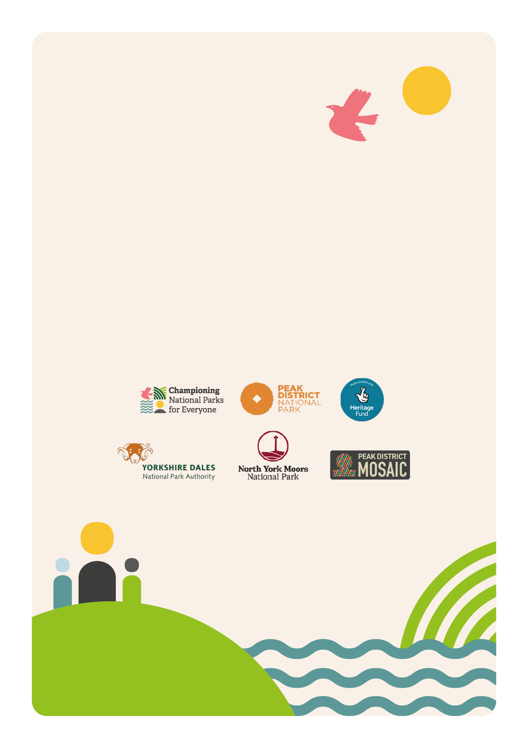
Community Champion Training:
Application Form

Community Champion Training: Application Form
The Community Champion Training Programme is the heart of the Championing National Parks for Everyone project. Each National Park is delivering the Community Champion Training programme three times. There is capacity for twelve adults per cohort of training. This training is for adults from ethnically and culturally diverse communities, who would like to develop their confidence and leadership so that they can share National Parks with their communities. The training is free.
As numbers are limited, we have a short application form for you to fill out:

Basic Information
Full Name

Date of Birth

Email Address

Telephone Number

Ethnic background

Medical Information
Any medical information we should be made aware of?

Any disabilities or specific considerations we should be made aware of?

We would like to understand a little more about you. Please answer the following questions in 100 words or less;
- What sparks your interest with this training?

- How do you intend to use this training?

- We have a small bursary for participants of training to support with travel, equipment and childcare. Would you require a bursary? Please give details.

- Where did you hear about the Community Champion training?

Timeline:
- Date – March 2025
- Applicants notified ASAP
- Community Champion - Day 1 COHORT2
(Date – 21st June 2025)

Thank you.
Please send completed form to J.barnard@northyorkmoors.org.uk

