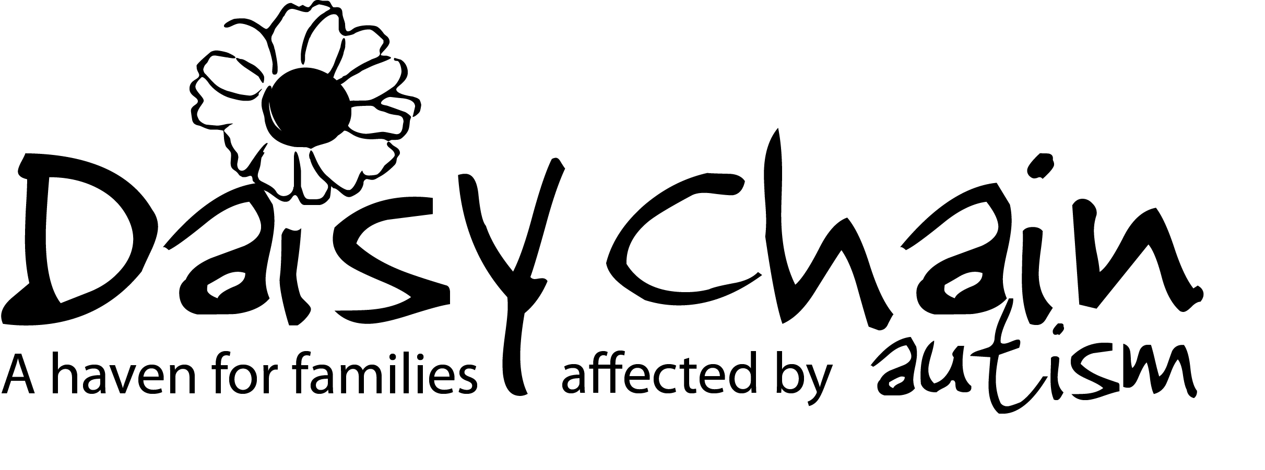
Join our volunteer team
Volunteer Application Form

Telephone (Home):

Telephone (Mobile):

Email:

How did you hear about volunteering with Daisy Chain?

Daisy Chain Volunteer: 

Knowledge of Daisy Chain: 

Daisy Chain Superstore: 

Daisy Chain Website: 

Social Media: 

Other (Please specify):

About You

Title:

First name:

Last name:

Preferred name:

Date of birth (Volunteers must be 16 or over):

Address:

Postcode:

Please indicate how you would like to help Daisy Chain

Let us know what areas of Daisy Chain you are interested in by ticking one or more of the boxes below or if you are interested in a specific volunteer role that has been advertised, please let us know.

Farm/Barn:  Superstore: 

Fundraising and events:  Care (working with children): 

E-commerce:  Care (working with adults): 

Office Administration:  Gardens and site: 

Wellbeing Service:  Family Support: 

Title of advertised role:

If you have relevant experience in any of the areas you have ticked, please provide details:
______________________________________________________________
______________________________________________________________
______________________________________________________________

About your skills and experienc
Your availability

Please let us know the days and times that you are available to help support us. We appreciate that the days and times that you are available may change so this will only be used as a guide.

Simply tick in the relevant boxes where you may be able to volunteer. If you are unable to give set days or times please tick here 

 | Monday | Tuesday | Wednesday | Thursday | Friday | Saturday | Sunday
AM
PM
EVE

Please tell us what your current status is.

Your current status | Student Employed Self-Employed Retired  Unemployed Other (please specify) __________________________

References

Please provide us with the details of two people who can give you a reference. This can include current or previous employers and people or other organisations that you have volunteered. Please only use people that you have known for at least two years and that are not a relative.
Reference 2

Name:
How do you
know this person?

Address:

Postcode:

Telephone:

Email:
Reference 1

Name:
How do you
know this person?

Address:

Postcode:

Telephone:

Email:

Your health

Your health needs

Do you have any health issues or medical conditions that you think we may need to know about? (this can include medication and/or allergies).

General Data Protection Regulation

I give my consent for Daisy Chain to store the information about me described in this form so long as it complies with GDPR requirements (please tick) – Yes  No 

I understand that I have the right to withdraw my consent at any time but without my contact details Daisy Chain will not be able to contact me regarding volunteering (please tick) – Yes  No 

Disclosure Barring Service (DBS)

Due to the nature of the work here at Daisy Chain it will be necessary for you to undergo a DBS criminal record check. All positions are exempt from the Rehabilitations Act 1794 (ROA).

Applications from ex-offenders are welcomed and will be considered on their merit. The amendments to the Exceptions Order 1975 (2013) provide that certain spent convictions and cautions are ‘protected’ and are not subject to disclosure to employers, and cannot be taken into account. You are required to disclose any convictions that are not ‘spent’ by virtue of the Rehabilitation of Offenders Act 1974.

For legal and accounting professions, you are required to disclose all convictions, including those that are spent by virtue of the Rehabilitation of Offenders Act 1974 (Exceptions) Order 1975 (as amended in 2013).

Do you have any convictions, cautions, reprimands or final warnings that are not ‘protected’ as defined by the Rehabilitation of Offenders Act 1974 (Exceptions) Order 1975 (as amended in 2013)? (please tick) – Yes  No 

Signed: Print name: Date:

Please return your completed form to;

volunteering@daisychainproject.co.uk

or post to Volunteer Department, Daisy Chain Project, Calf Fallow Farm, Calf Fallow Lane, Norton, Stockton-on-Tees, TS20 1PF.

