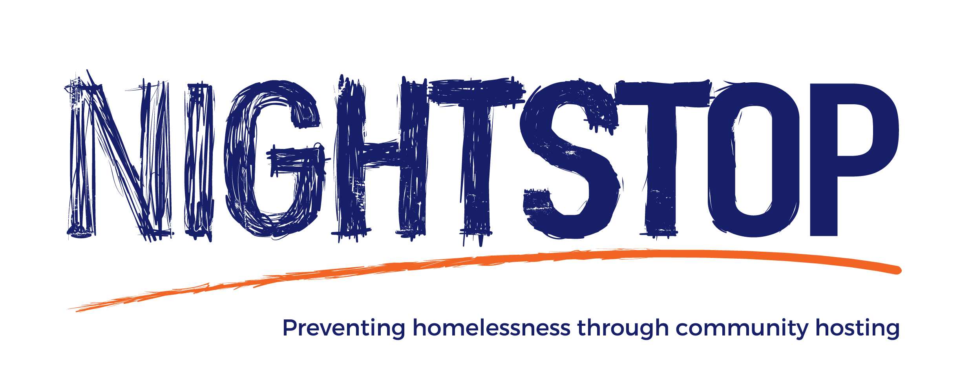

NIGHTSTOP VOLUNTEER APPLICATION FORM

volunteer application form
Thank you for your interest in becoming a Nightstop volunteer. You should have the following information to help you with your application:

- Role Description
- Application form
- Equality and Diversity Monitoring form

We take volunteering seriously, and want to help volunteers feel as prepared and supported as possible.

COVID-19
Please note that due to the ongoing COVID-19 (aka coronavirus pandemic), there are some temporary changes to the procedures involved in assessing and training new volunteers in order to reduce risks for both volunteers and Nightstop staff. Essentially, this means that most aspects of the process will now be carried out remotely (e.g. via video call) rather than in-person.
Nightstop has a duty of care not only to the young people we support, but also towards the volunteers that we work with. This means that unfortunately, applicants falling within groups deemed to be at higher levels of risk from COVID-19 will temporarily be ineligible for volunteering in Nightstop roles that would require a level of in-person contact with Nightstop guests (e.g. hosts, drivers, chaperones). If this applies to you but you would still like to support Nightstop, then please contact your local Nightstop service to discuss the possibility of volunteering in a non-contact role. You can also get in touch with Nightstop UK (the national organisation which oversees the network of Nightstop services) at nightstopuk@depaulcharity.org.uk to discuss alternative volunteering roles.
For these reasons, a short COVID-19 screening section has been added to this application form. If you have any questions about this or any other aspect of the volunteering role in relation to COVID-19, please get in touch with Nightstop North East and Cumbria

The application process
We will contact you within 10 working days of receiving your application to discuss your application in more detail, and to arrange the next steps. If we agree together to carry your application forward, we will then arrange a video call as part of the next stage. This is then followed by training, which will be delivered remotely. For hosts, there will then be a home assessment, mainly carried out via video call and then confirmed with a final home visit.
All this information is then presented to our volunteer recruitment panel who will approve you as a volunteer. If you are unsuitable for this role we will let you know, and we may discuss more suitable, alternative roles for you. We will delete your personal information after 12 months of applying.
Please note we aim to promote equality of opportunity for all with the right mix of talent, skills and potential. Depaul welcomes applications from people from all backgrounds. If you require information to be sent to you in an alternative format please let us know by contacting NightstopNE@depaulcharity.org.uk or 0191 2536164.

We take good care of your details and they are always safe with us. You can find out more by accessing our privacy policy at uk.depaulcharity.org/privacy-policy-statement.

If you would like any more information or help with your form you can email NightstopNE@depaulcharity.org.uk or NightstopCumbria@depaulcharity.org.uk or call 01912536164 for the North East and 07958 447477 for Cumbria

Good luck,
The Nightstop Team.

COVID-19 Screening
These questions are designed to assess whether you may fall into an at-risk group in relation to COVID-19. Please indicate whether each item on the list applies to you and/or a member of your household and/or a member of a support bubble.
 | Yes | No | Details
Is anyone in the household and/or a support bubble aged 70 or older? (regardless of medical conditions)
Is there anyone in the household and/or a support bubble under the age of 70 with an underlying health condition listed below: | Yes | No | Details
Chronic (long-term) respiratory diseases, such as asthma, chronic obstructive pulmonary disease (COPD), emphysema or bronchitis
Chronic heart disease or serious heart conditions, such as heart failure
Chronic kidney disease

Chronic liver disease, such as hepatitis

Chronic neurological conditions (affecting the brain or nerves), such as Parkinson’s disease, motor neurone disease, multiple sclerosis (MS), a learning disability or cerebral palsy
Diabetes

Problems with your spleen – for example, sickle cell disease or if you have had your spleen removed
A weakened immune system as the result of conditions such as HIV and AIDS, or medicines such as steroid tablets or chemotherapy
Being seriously overweight (a body mass index (BMI) of 40 or above)
Those who are pregnant
Those that have had an organ transplant
Those that are having chemotherapy or antibody treatment for cancer, including immunotherapy
Those that are having an intense course of radiotherapy (radical radiotherapy) for lung cancer
Those that are having targeted cancer treatments that can affect the immune system (such as protein kinase inhibitors or PARP inhibitors)
Blood or bone marrow cancer (such as leukaemia, lymphoma or myeloma)
Those that have had a bone marrow or stem cell transplant in the past 6 months, or are still taking immunosuppressant medicine
Those that have been told by a doctor they have a severe lung condition (such as cystic fibrosis, severe asthma or severe COPD)
Conditions which mean there is a very high risk of getting infections (such as SCID or sickle cell)
Those taking medicine that makes them much more likely to get infections (such as high doses of steroids or immunosuppressant medicine)

If you respond “yes” to any of the above, please contact your local Nightstop service at 01912536161 before continuing with your application. The conditions listed above in the screening tool reflect current UK government and NHS guidance about groups which are at higher risk (clinically vulnerable and extremely clinically vulnerable) from coronavirus, and will be reviewed and updated in line with changes to this guidance. This guidance is available here for reference.

Your personal details
Name of primary applicant
Date of birth

Name of secondary applicant (if applicable)
Date of birth

Address
Postcode

To arrange the next stages of your assessment process should you be successful, it’s useful to know how best to reach you. Please share those details below.
 | Contact details | Preferred option
Home

Mobile

Work

Email address

Why you want to be a Nightstop volunteer
In your own words, please tell us why you are applying for this position and what you hope to gain from your time as a volunteer with Nightstop

Please give details of any relevant work, voluntary, training and/or life experience that you have that might be relevant to this role. (Please continue on a new page if necessary). Please include any skills you think could assist a person with specific requirements i.e. sign language, caring for someone with a disability, any languages you speak.

What skills and knowledge do you think an effective volunteer could bring to Nightstop and to the people who use the service?

What challenges do you think the people on Nightstop face, and what type of assistance may they need to overcome them?

What challenges do you think you might face within your voluntary role?
Do you have any needs that require our support to enable you to become a volunteer for Nightstop? Alternatively please provide details on a separate sheet and place in an envelope marked ‘Private and Confidential’ and send it to us with your application.

Nightstop hosts only*:
If you became a Nightstop Host, how do you think you might spend your evening if you had a young person staying with you?

Your Home
Please tell us about who else lives in your house. This helps us understand a little bit more about the home, and the potential placement for young people. Anyone over the age of 16 years will be required to undergo a Disclosure and Barring Service check.

Name | Previous names | Relationship to you | D.O.B

Do you have any pets?  If yes please give details | YES NO

Do you have a private spare room with a bed that can be used by a young person?  If NO, when do you anticipate that a room will be available? | YES NO

Are you the owner of the property? | YES NO
If NO, have you made your landlord aware of your intentions to undertake the role of Nightstop host? | YES NO

References
Please provide the names and addresses of two referees, at least one (but preferably both) of which should know you in a professional capacity - e.g. employer, volunteer manager, teacher etc. These references will form part of the assessment process and we will contact them in the next 2 weeks.
Referee one | Referee two
Name | Name
Address | Address
Postcode | Postcode
Email | Email
Tel No. | Tel No.
Relationship to you | Relationship to you

Criminal Records
As we meet the requirements in respect of exempted questions under the Rehabilitation of Offenders Act 1974, applicants who are offered employment or volunteering opportunities with vulnerable young people or in positions of financial responsibility will be subject to a criminal record check before the appointment is confirmed. This will include details of cautions, reprimands or final warnings, as well as convictions.

Any information given will be confidential and will only be considered in relation to an application for a position to which the order applies. We would like to stress that having a conviction or caution will not necessarily prevent you from gaining a volunteer placement with us.

Do you have any previous cautions or convictions? | YES NO
Only for volunteers who will be driving Nightstop guests:  Do you have any driving offences or points on your licence?  If YES, please provide details on a separate sheet and place in an envelope marked ‘Private and Confidential’ and send it to us with your application. | YES NO

Further information about Nightstop and Depaul
If you are successful as a Nightstop volunteer we will be in touch with information about the role, your availability for the rota and any other relevant information regarding your role as a volunteer. If you are unsuccessful we won’t keep your information.

We would love to keep you up to date with our latest news, stories from young people and ways to get involved including giving to Depaul UK (including Nightstop UK). Please tick ‘yes’ or ‘no’ to let us know if you’d like to hear from us:

Post YES NO

Phone YES NO

Email YES NO

SMS YES NO

DBS Privacy Policy Declaration Form

DBS Statement of Fair Processing
Disclosure and Barring Service (DBS) process applications for Standard and Enhanced Checks.
By completing the DBS application form and providing personal details, you agree to accept and be bound by the Privacy Policy, which explains how DePaul UK processes your data for the purposes of obtaining your Disclosure from DBS, the key terms of which are summarised in this statement or processing.
Data on the form may only be recorded and changed by you the applicant. If you require advice on answering question 55 please contact the DBS on 03000 200 190.
By signing this, document applicants completing a DBS form confirm that, as I am applying for DBS Standard and Enhanced Check I have read the Standard/Enhanced Check Privacy Policy for applicants,

https://www.gov.uk/government/publications/standard-and-enhanced-dbs-check-privacy-policy/standard-and-enhanced-dbs-check-privacy-policy

and, I understand how DBS will process my personal data and the options available to me for submitting an application.

Signed: ------------------------------------------------------------------------------
Name PRINTED: ------------------------------------------------------------------------------------
Date: -----------------------------------------------

Declaration
I confirm that the information I have provided on this form is correct to the best of my knowledge.
Print name: Signed
Dated
Print name: Signed
Dated

Please return your completed application form to:
For the North East  Nightstop North East  Depaul UK  Oxford Street  Whitley Bay  NE26 1AD  NightstopNE@depaulcharity.org.uk | For Cumbria:  Nightstop NE & Cumbria  Depaul UK  28 Lowther Street  Carlisle  Cumbria  CA3 8DH  NightstopCumbria@depaulcharity.org.uk

