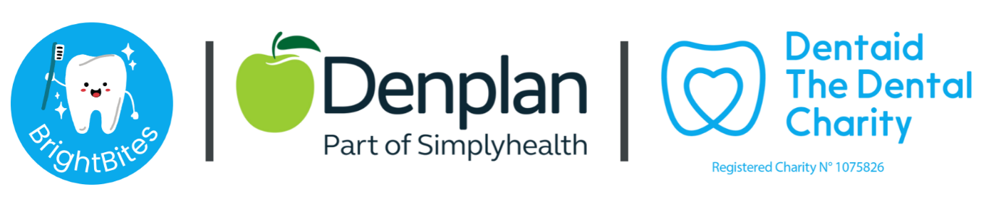

To become a BrightBites volunteer, you will need to complete the application form link which can be found here

The information contained in this application form will aid the DBS process and provides us with more information about you and your area.

Following receipt of the application, we will send you an email with further details.
You can also find more information about BrightBites on our website here

Thank you for considering becoming a BrightBites volunteer!

